COEL: The focus of this half term will be on MOTIVATION being involved and keeping trying. Dojo Jobs will be used to encourage thinking and independent skills 
Literacy – reading and writing confidence:
The Lion Inside and non fiction books about animals: Our texts focus on inner confidence and animal facts.
We will continue to focus on listening and attention skills, maintaining attention and sitting for carpet time. Our reading journey will continue to grow as we focus on blending phonemes and recognise tricky words. Your child will continue to bring home Phase 2 phonic books which they should be able to read at home to you. They will also bring home a coloured book band which they will use their comprehension skills of using pictures to help with unfamiliar words – this is a book to share and support your child with. Our writing focus will be on developing resilience to have a go at labelling and writing simple captions / sentences. We will continue to develop our fine motor skills through daily handwriting sessions.

Maths mastery– having confidence and being resilient
We begin our daily maths sessions with Mastery in number followed by a ‘Fluency Frenzy!’
In our group work time, we will be looking at shapes with four sides, height and weight and 3D shapes. We will continue to practise subitising skills; looking at the composition of numbers within 10; and finding out 1 more / 1 less. As maths is all around us we will continue to find mathematical opportunities within all aspects of our learning. Children have access to NUMBOTS at home to further practise early number skills

Understanding the world: God’s Wonderful World –active and inquisitive learners. We will be spending our time exploring the joys Winter brings. We will focus on different animals which live in different parts of the world starting our work on sorting. Further into the half term, we will use our investigative skills to find out about dinosaurs.
British Value
Tolerance of others
PSHE Valuing Differences – SCARF
Safe Relationships
RE Stories Jesus Told

Christian Values
Courage

Friendship Confidence Sharing

Toy Story
Animals around the World
Bold Christian Values Resilience Strong Relationships Active Learners partnership
Courageous Confidence Thirst for knowledge Growth Mindset SUMO Forest School Enrichment
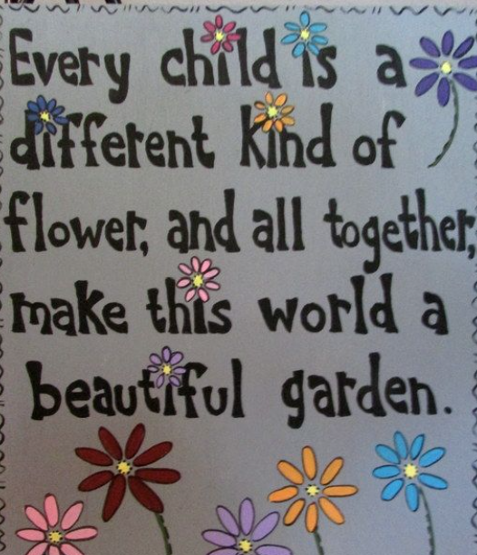
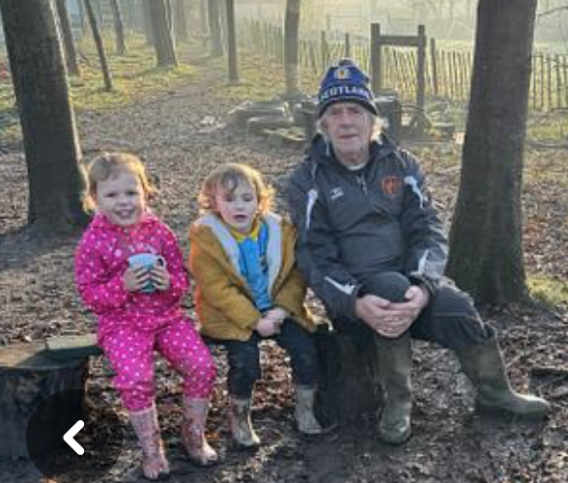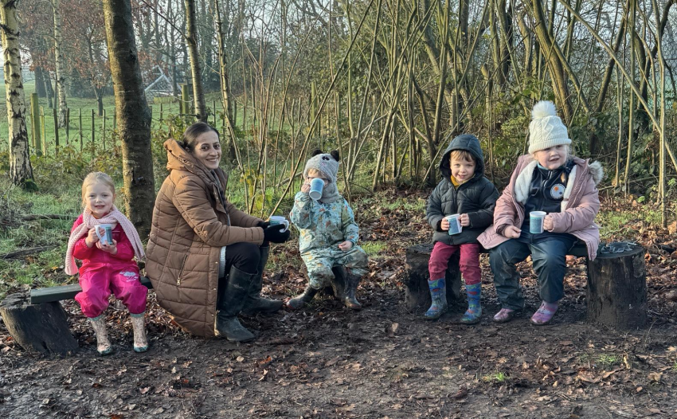
Communication and Language –
We continue to focus on use of correct vocabulary from names of animals, fruits to our body parts
We are all wonderfully and fearfully created. Psalm 139:14
Phonics – confidence and active learners-
Nursery :We will continue our Phase 1 Phonics which is based around sounds in the environment, instrumental sounds, body percussion, rhythm & rhyme, alliteration, voice sounds and oral blending & segmenting.
Reception : During this half term, children will write their own names confidently. Phonics games will be in the provision with a focus on hearing initial sounds, segmenting and blending. Children will take home individual reading books, sounds and tricky words.
Phase 2 phonics – ll,ss
Phase 3 phonics – j,v,w,x,y,z,zz,qu,sh,ch, th, ng
Read tricky words : he, she, we, me, be, was, you, they, my

Physical Development- confidence, partnership, strong relationships:
During this half term, we focus on developing the core strengths to enable your child to develop both gross motor and fine motor skills. This will be done through co-operative play, Forest School, learning through play outdoors, handwriting sessions and carefully planned fine motor skills activities.
Forest school : Tuesday. PE : Friday. Please send your child into school on these days in their PE kits.

Achieving excellence within the light of God.



