**Discovery Newsletter Summer 1 2023**

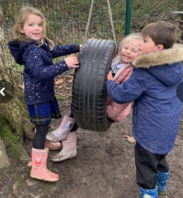Welcome to the Summer Term; we hope you have all had a lovely Easter break!

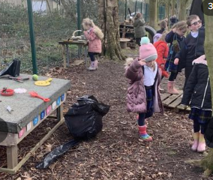 This half term our topic will be **‘The Great Outdoors’,**

so we will continue with lots of outdoor learning which our

class love! We look forward to welcoming you into school

for Discovery’s WOW watch this half term ☺

Our topic web can be viewed on the school website under Classes Discovery-what’s new? We will also pop it on Dojo for you to see.

**Curriculum Information:**

* Maths, English, guided reading and phonics are taught daily alongside other areas of the curriculum.

**Reading:**

Our focus on reading is to build **fluency**, **confidence** and **pleasure**. We will do this through teaching your child to apply phonic knowledge, blending sounds in unfamiliar words and reading common exception words. We ask that your child reads every night that you record this in the reading record book. ☺ Bingo boards with sounds/tricky words your children need will continue to come home for some children, please practise lots and when your child is secure new words/sounds will be sent home. **It is vital for your child’s progress that your child reads every day at home**.

Our Year 1 children are working towards their Phonics Screening which takes place in June. We have identified any areas which your child needs extra consolidation on – during the week they will have some 1:1 time recapping and consolidating. On occasions, extra reading/phonic work will be sent home which is specific to your child, where necessary.

Thank you to everyone supporting homework, it really does make a huge difference.

**Maths:**

Maths and fluency are taught every day. At home please continue to practise counting forwards and backwards, one more/one less, subitising, counting in 2s, 5s and 10s and number bonds to 10 and 20.

**Times Tables, Maths Homework and Spelling:**

* Reception – new tricky words will be sent home for you to

read and spell

* Year 1, please play Numbots regularly.
* Spellings will be sent out every Monday. These will be based on the graphemes we have been teaching plus any common exception words or tricky words. Our **Spelling Quiz will be the following Monday giving all children the full week and weekend to learn their spellings.**

PE:

**Please ensure your child has their labelled PE kit in school (including pumps/trainers that fit).**

* **Tuesday:**  with Mrs Mesghali/ Miss Rawsthorn.
* **Thursday:**  with Miss Topping. (Year 1 only)

As always, our door is always open and you are welcome to come and speak with us. Our Class Dojo is checked daily and any messages answered as quickly as we possibly can.

Thank you for all your support,

Mrs Mesghali, Mrs Hothersall and Team Discovery!