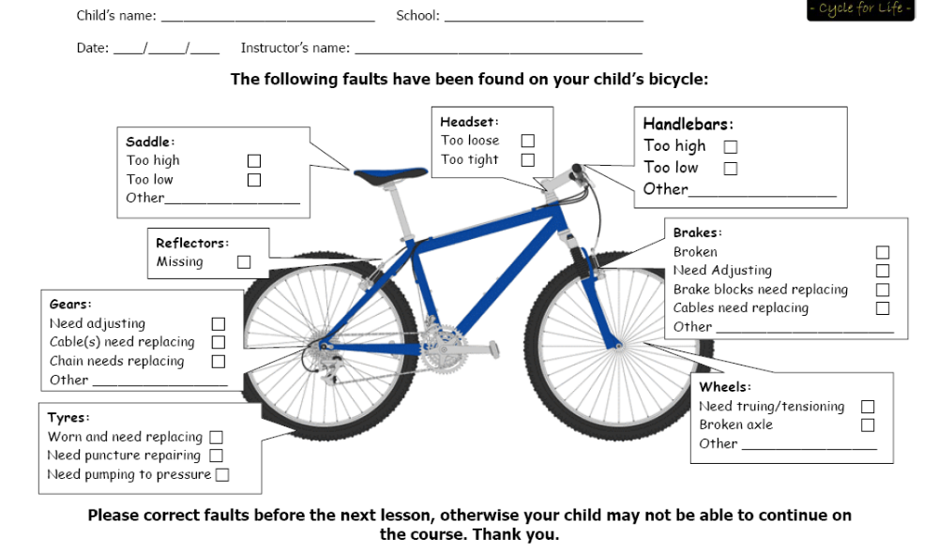


Please ensure that your child’s bike has been checked and in good working order prior to participation onto the course

