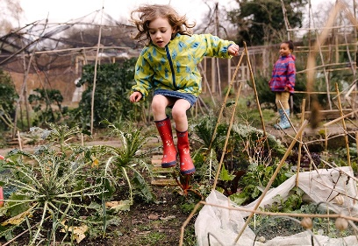

**R.E.** Why is Baptism special? We will deepen children’s understanding of what it means to belong through exploring the celebration of baptism and the ways in which people of faith welcome babies.

**Computing :** Digital Research searching for information related to The Great Outdoors. Creating Digital Content - adding text and images. Use of the keyboard- dance mat typing BBC website

**English:**

We will be innovating our own narrative based in a familiar setting, using descriptive words and phrases to describe characters and settings. We will use a Percy the Park Keeper story : After The Great Storm

We will then write our own information booklet on an area of the great outdoors. We will look carefully at the features of this text type and make sure we use them in our own writing.

Finally, we will look at traditional skipping rhymes and write our own rhyme, linked to our topic of the outdoors.

**Music.**

As musicians we will be learning to sing along to friendship songs. We will continue our focus on improvisation and composition.We will also be listening and appraising Rimsky-Korsakov’s  **Flight of the Bumblebee**

**PE.**

This theme introduces the children to trails. These provide a variety of learning opportunities including observation, self-resilience, route finding and memory. The children will be following and making their own trails within the outdoors.

**Science.**

During our science topic this half term the children with be scientific explorers in search of ‘special treasure’, some of which they will find in the great outdoors! The focus of this topic is materials and their properties.

The children will search for objects of different materials, e.g. metal, glass, paper, crockery, fabric, wood and plastic. The pupils will look for these and state some of their properties.

The children will sort/group/compare the objects and find the odd one out. The children will explore man-made and natural objects and carry out some practical investigations.

**Geography:**

We will be observing the geographical features within the great outdoors in our local area, both natural and man-made, e.g. fields, ponds, car parks, roads, fences, lawns, paths, water, trees. We will begin to use positional language linking to our maths and use a compass to locate north, east, south and west. We will draw and create maps using simple keys and look at how seasonal changes affect our area.

**DT :** Children will research, investigate, design and make a piece of playground equipment suitable for a small world figure linked to Percy and his friendly animals. The pupils will also discuss which materials will be best suited to this product and why.

**Art** : As artists, the children will be looking at how shadows are formed with small world figures and using different techniques to develop the use of tone by shading showing dark and light.