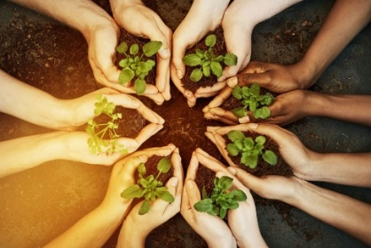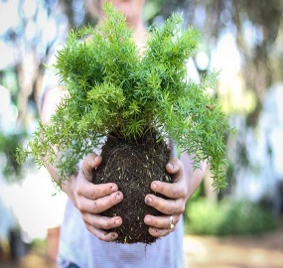

**DT**: Our theme will be create a fruit kebab for an Easter picnic. We will be tasting lots of different fruits and developing our vocabulary at the same time.

**RE : Multi Faith Week** Celebrations and Food. What celebrations do religions have and what do they eat at them?

**Easter, New Life**: we will reflect upon the miracles of nature and new life during springtime. We will hear and retell the Easter story and make links between transformation of plants/animals and resurrection.

**Art**: Our theme will be flowers and gardens. We will focus on the skills of observational drawings and painting. Following this, we will look at how to take our ideas and create a print from it (Watch this space mums as there may be a special card coming your way on the 22nd of March)

**Science**: Get your gardening gloves at the ready! Our science learning sees us continuing with our Nature Journal work linked to our school ground. During this unit we look at being able to : identify and name a variety of common wild and garden plants, including deciduous and evergreen trees; and identify and describe the basic structure of a variety of common flowering plants, including trees.

We are also hoping to have a visit to a plant nursery to see how the process works

**PE :** Yoga – South Ribble Sport Coaches (Tuesday)

Invasion Games- Netball/Football Mrs Horn/Mr Pitcher (Wednesday)

Growth and Green Fingers – Discovery Year 1 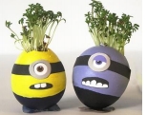

**English**: We begin this half term looking at the classic story ‘The Enormous Turnip.’ Our focus will be on orally retelling this story using story telling actions. Once we know this story well we will be using our innovation skills to change and write our own story based upon this theme. In our grammar, we will be focussing on the use of exclamation marks. Our word level work sees us spotting the suffixes – ed, -ing, -er and -est onto root words where there are additional no spelling rules.

We will then be looking at instructions focussing on how to follow and write them. We will finish the half term studying traditional rhymes writing our own rhyme based around plants.

Within our reading we will be looking at: a story from another culture in Mama Panya’s Pancakes; Alice in Wonderland, which will link to our World Book Day theme and reading a different version of Jack and the Beanstalk.