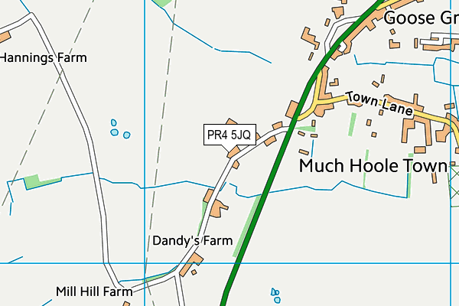Year 1

**Christian Value –** Love and compassion

**R.E.-** In our R.E lessons this term, we will be looking at the story of Christmas and the journey to Bethlehem which will fall in line with our Nativity performance.

**Enrichment:**

As part of our history topic we will be coming to school dressed as children from the Victorian era. We will look at how our school may have been different all those years ago. We will also enjoy a whole school Geography day where we will travel around school visiting different countries from around the world. The children will learn all about WW1 during our whole school World War 1 week.

**PSHE**- We will be looking at keeping and understanding what is safe. We will also look to have an awareness of which adults the children can trust and who to go to for help if they feel unsafe.

**Art and Design.**

This half term we will be exploring the work of artists, craftspeople and designers from different times. We will use a variety of materials for printing and use our drawings to develop a simplified printing motif of school or our local area.

**History.**

During our history topic this half term, we will be looking at where we live and where we go to school. We will discuss how these places may have changed over time and become ‘time detectives’ who use maps, photographs, pictures and digital maps to look for evidence. We will ask questions about what it was like to live in our area a long time ago and look at how our school playground may have changed. We will come to school dressed as children from the Victorian era and live a school day as they would have done; playing games that they would have played and talking about how our school has changed.

**English:**

In English, we will be continuing to look at stories by Oliver Jeffers. Our first unit of study will be looking at poems with a theme. This will involve looking at the “How to catch a star” book by Jeffers and using his inspiration to write our own poems based on the stars. We will also be building on our knowledge of Non-Chronological reports linked to the local area. Also, we will be using the place where we live to write a narrative with a familiar setting.

**Geography:**

This half term we will be looking at the place where we live. We will be studying the local surrounding area and focusing on what has been built and what is natural in it. We will also be linking this to what the children do outside of school - Where do they visit? What do they do there? We will then use these places and locate them on a map.

**Maths:**

This half term we will continue to secure our practical and written methods when adding and subtracting numbers. We will use concrete apparatus to help us and apply what we know to reasoning and problem solving. We will also be looking at shape.