Y1 Discovery Newsletter Autumn 2 2019
Welcome back to a fun-packed half term. It was lovely seeing your children settle so well into our class. We can already see a big change in how much effort they are putting into working as a Year One.
This half term our topic will be ‘Where I Live’
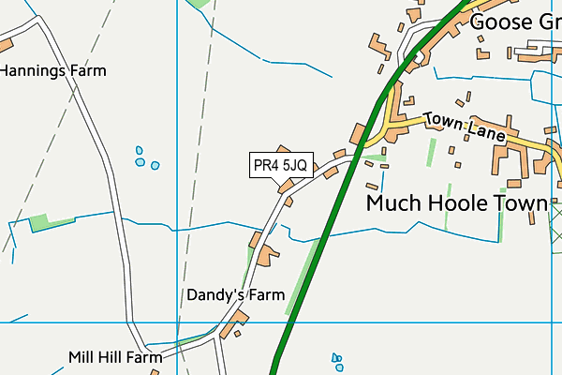

Our topic web can be viewed on the school website under Classes
Discovery-what’s new?
Curriculum Information:
- Maths, English, guided reading and phonics are taught daily alongside other areas of the curriculum.
- Reading:
Don’t forget : Children will always benefit from listening to grown-ups reading. This is where we really hope to foster a love of reading and enthuse your child. Reading for pleasure will be taught through your child listening to stories, poems, non-fiction texts, rhymes and fairy/traditional tales. There’s nothing better than listening to a good story or poem, perfect for bed-time chilling out time!
We ask that your child reads every night and that you record this in the reading record book. Please write a positive comment which we can re-iterate with your child. Then, add any additional comments you wish for us to see about your child’s reading e.g. If you think your child needs to re-read this book; if there are any words/graphemes your child has had difficulty with. It is vital that your child reads every day at home.

- Maths:
In Year 1, the focus within mathematics is to build fluency, problem solving and reasoning across all the mathematical strands. This half term firstly sees us focussing on addition and subtraction within ten. In class we are using lots of practical resources (manipulatives) to support your child – check out the Dojo for ideas. We ask that you continue to support your children through the maths homework set and focus on helping your child learn their number bonds within and to ten as this is a huge building block in helping them become fluent not only in Year 1 but for their rest of their primary education. Here is a free website link which is brilliant for this :
https://www.topmarks.co.uk/maths-games/hit-the-button. Remember little and often is the key.
Towards the end of this half term, we will be looking at 3D and 2D shape. Here we will be learning to recognise, name and sort 3D/2D shapes along with using them to develop our understanding of pattern.

Times Tables:
Please continue to encourage your child to access TTRockstars. After last half term’s focus in our maths mental starters, your child can now access X10, X2 and X5.
- Spelling:
Spellings will be sent out every Monday. These will be formed from the graphemes we have been learning plus any Y1 common exception words. Tests will be the following Monday giving all children the full week and weekend to learn their spellings.

- Homework:

PE:
Please ensure your child has their labelled PE kit in school.
- Tuesday,taught by South Ribble sports coaches and
- Wednesday, taught by Mrs Horn/ Mr Pitcher
- Daily, 10 minute run

Forest Schools – Forest school sessions have now started. Please ensure your child has suitable clothing as regardless of the rain we will be out there!

As always, our door is always open and you are welcome to come and speak with us. Our Class Dojo is frequently checked and any messages answered as quickly as we possibly can.
We are looking forward to working together with your children and yourselves this year!

Mrs Mesghali, Mrs Lever and Team Discovery!

Homework Y1
As per our homework policy which can be viewed on our website, homework for Y1 should take no longer than 1 hour per week.
It will consist of:
- daily home reading book
- weekly library book
- weekly spellings linked to phonics phases
- weekly maths homework: ‘Mathletics’ on line resource (set by teacher) or a maths game/activity
- occasional project work linked to other areas of the curriculum

Year 1 common exception words
This is a word list taken from the National Curriculum of recommended words a Year 1 child should be confident spelling as they complete Year 1.
The A Do To Today Of Said Says Are Were Was Is His Has I You Your They Be He Me She We No Go So By My Here There Where Love Come Some One Once Ask Friend School Put Push Pull Full House Our
Here is a website which may be of use : https://www.theschoolrun.com/spelling-in-year-1

