 | Monday | Tuesday | Wednesday | Thursday | Friday | Daily Skills
Maths | Lesson 1.  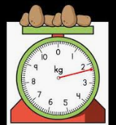  White Rose - measure mass.  After completing the worksheet, get out the kitchen scales and have a go at working practically to compare the weight/mass of different objects. You could begin to introduce the units on scales and talk about the intervals (what does the scale jump up in?)  Why not then, put all of this in to practice and follow a recipe/do some baking?  Maths Challenge- Hundred square dilemma. | Lesson 2.  White Rose- compare mass.  Once you have completed the maths worksheets you could have a go at becoming a real life human scale. Close your eyes and stand with your arms outstretched whilst your parent or sibling hands you 2 objects. You have to think carefully about which item feels heaviest and then test whether you are correct using proper scales.  Maths challenge- missing numbers.  Can you fill in the blank hundred square?  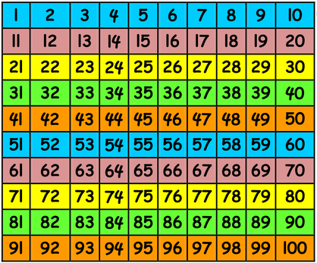 | Lesson 3.  White Rose- Introduce capacity and volume.  Complete the worksheets and then gather up some bottles, jugs, containers, cups and pans. Have a play in the garden filling them up with water. Use the vocabulary full, half full, almost full, empty, almost empty.  Can you work out…  - How many cups you need to fill the pan?  - How many bottles of water half fill the jug?  - Which container holds the most water?  - How can you test this?  - Does the tallest container hold the most water?  Maths challenge- Can you count forwards in your 2x, 5x and 10x tables?  Who can count backwards? | Lesson 4.  White Rose maths- Measure capacity.  Complete the worksheets.  Maths challenge- Practical Capacity. Make your own magic potion!  (See class story dojo for ideas.)  - Begin to look at the units on measuring jugs.  - Carefully measure liquids using jugs of varying sizes and capacities.  - Most importantly, have some fun with water and make your own magic potion! | Lesson 5- classroom secrets. Compare capacity.  Choose the worksheet that you think is appropriate for your child. (They are differentiated, starting with one that may be a little easier, then getting a little harder with sheet 3 being the hardest.)  Maths challenge.  Chilli Challenge questions including the use of greater than, less than and equal to symbols. | Numbots – use TTRockstars login  Hit The Button  BBC Bitesize  Emile  Counting forwards and backwards (from random starting points) whilst you climb the stairs.
English | Information poster.  Read the book below recommended in the daily read section, or if you are unable to, then just think of your favourite bugs/minibeasts. I would love you to create your own fact poster all about these bugs. I want you to include factual sentences, pictures, labels, captions and maybe an ‘amazing fact’ box with a lift up flap!  Take extra care with your handwriting and presentation. Think about making your poster eye catching and bright so that it catches people’s eye and makes them want to read it.  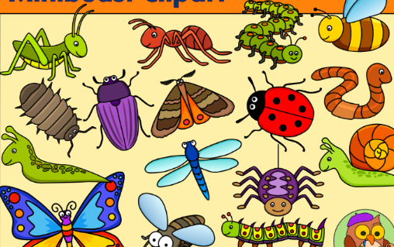 |  | Party invitation sentence writing.  After reading the book ‘Arthur’s Fantastic Party’, design and make your own party invitation to your pretend birthday party.  Write your invitation to your friend telling them about what games you will play at your party, the food you will make and what time to arrive. Don’t forget to write your address so they know where to come.  Remember to include capital letters, full stops, careful spelling and check your sentences make sense. | Instructions.  Following on from the maths work that you have done, write your own set of instructions for how to make you magic potion.  Remember to include-  - A ‘How to’ title  - A ‘You will need section  - Numbers to order your instructions  - Time connectives (First, then next, after that) to order your instructions  - Imperative verbs (put, pour, mix, sprinkle, get) | Writing lists.  Start with the handwriting sheets and practise carefully forming your letters.  Then think about if you were going to go to the seaside for the day, what would you need to take with you?  Using your most beautiful letter joins and cursive handwriting, write a list of all the things you would take. Keep the list somewhere safe for the next time you take a trip to the beach. | EMILE  BBC Bitesize Games:  Karate Cats
 | Daily Read  Go to the oxford owl website and read/share this turquoise book with your parent or older sibling. Can you find the pictures, labels, captions and blurb?  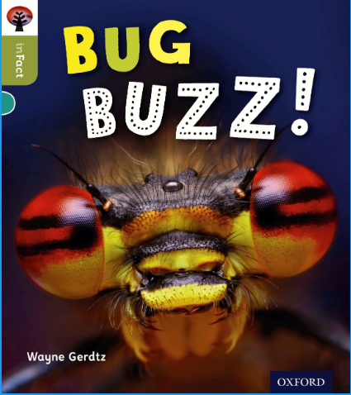 | Daily Read  Have a look through your book shelf at home and pick out some of your favourite books. Get a drink and some snacks and then enjoy looking and reading through them. | Daily Read  Go on the Collins connect website and read this story (orange book band)  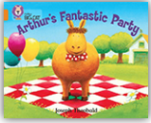  Talk about the feelings of the characters at different parts of the story. | Daily Read  Listen to the book ‘The lion inside.’  https://www.youtube.com/watch?v=GlfDD3gYZ_0  Talk about the characters. What adjectives would you use to describe the lion and the mouse throughout the story?  Do these adjectives change as the story goes on? | Daily Read  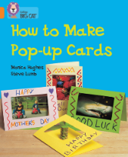  Go on the Collins connect website and read this story (orange book band)Afterwards, why not have a go at following the instructions and having a go at making your own pop up card for a friend or family member to make them smile. | Go to the website and use this login information-  Username- parents@harpercollins.co.uk  Password- Parents20!  Oxford owl- set up using your email address.
Phonics and  Spelling | Spelling list for the week  Alternative spelling for the /ee/ phoneme.  Treat  Funny  Donkey  Sweet  Heavy  Reading  Thief  Field  Maybe just focus on a couple each day. Try to be creative in the ways that you learn them; use chalks on the pavement, paint the words on paper, spell the words in sand, trace them on your parents back and they have to guess the word! | Grab a dice and some counters and play this game where you need to read these nonsense words!  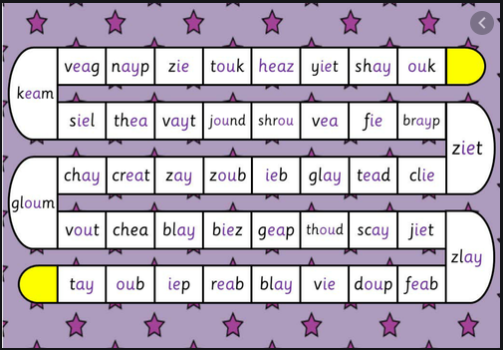 | Have a play around on the ‘PhonicsPlay’ website.  https://www.phonicsplay.co.uk/BuriedTreasure2.html#  This game here is one we play in school. | Make posters with  /ee/  /ea/  /y/  /ey/  /ie/  on them and stick them around your room or garden. Your parent says one of the spellings from Monday’s list and you have to run to the correct grapheme. | 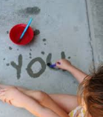  Get yourself a paintbrush and some water and have a go at spelling some of the 100 high frequency words or Year 1 Common exception words that you find a little difficult on the flags in your garden or on your driveway. | There are lots of activities on emile too.  There is also a nice spelling and typing activity here : https://www.doorwayonline.org.uk/activities/speller/
Topic | Geography/History-  Use google maps/google earth to find some seaside resorts that you have been to either in this country or in another country. Talk about your memories of being here. What did you play? What did you enjoy? What things could you see whilst you were there? Do you think that the seaside has changed over time? In what way? (Encourage lots of discussion! Parents, talk about your memories when you were a child and compare them to now.)  Science.  Thinking about the seaside, what objects might you see there? What materials might these objects be made from? Are the natural or man-made materials? Complete the activity sheet by cutting and sticking the pictures in to the correct place on the table. Can you add some pictures of your own?

