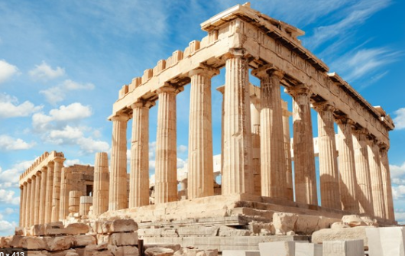

**Art:** Focus artists Patricia Coates and Alberto Giacometti

Studying the human form and creating statues or sculptures is a legacy from Ancient Greece. This half term we will be following in their footsteps and aiming to create accurate human drawings. Our theme will be sporting events and recreating Olympic poses. We will develop our drawings in paint, collage and finally in 3d sculpture to create a figure in action. We will also use digital media to help us create accurate poses. **Local Link: Anthony Gormley Crosby Sculptures.**

French: En Vacances! Vocabulary about going on holidays.

**Music – Tunes for a Purpose**

This half term we will be exploring the mood of music and how different durations, melodies, dynamics and tempos. We will have the chance to use our own musical preferences to create a variety of personal playlists. We will start by making a playlist to exercise to, moving on then to a work playlist, a more relaxing choice and then finally a sport anthem.

**English:** 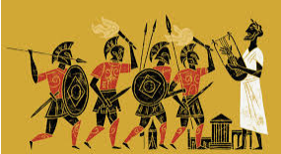 

To finish the year we will be visiting three types of texts. The first of these will be myths of Ancient Greece. We will also be enjoying our Ancient Greece themed class novel via our You Tube channel. Our aim will be the write our very own myth! Secondly, we will be learning how to write a non-chronological report, providing information all about an aspect of the Olympic Games, linking the ancient to the modern. Finally, we will finish the year with a spot of poetry. Our focus will be on figurative language, what this means, spotting it and finally using it in our own work.

PE:

Daily Mile

Yoga and Go Noodle – linked to PSHE

Sports Coaches – managed by South Ribble Sport Partnership

**Ancient Greece Sport Challenge:**

* Exploring the Ancient Games
* Motto of the Olympics
* The three runs challenge
* The three jumps challenge
* The three throws challenge

Link to British Values – comparison.

**Computing – Coding**:

This half term we will be learning to use computer programs that require coding. Starting using Tynker we will be learning to story tell, make games and design quizzes all with an Ancient Greek theme. We will also be using the SketchUp program to explore 3d modelling of Greek temples.

**Safety:** Social media safety – high school ready!

**Christian Value – Respect**

**R.E –** Christian Peace

Transition supported by the diocese for Year 6 pupils. Live Leavers’ Service planned for July.

**PSHE: Returning to School, wellbeing and changes:**

After being away from school for such a length of time, we will be making such we return to school in a way that is calm and relaxed. We will be learning techniques to reduce our anxiety and talk together about our worries. Summer term is also a time of reflection and change. We will be supporting this through our Talking about Secondary School resources and working with our local high schools. Finally, with summer holidays on the horizon we will be learning all about being a risk taker and staying safe.

**Ancient History: The Greek Civilisation**

Our last destination of the year takes us to Ancient Greece where we enter a world of Gods, Goddesses, Olympics, warfare and democracy! The focus of our journey back into the past will be on the many discoveries of the Ancient Greeks. We will see how their developments in medicine, politics, buildings and sport affect our lives today. We will begin with the geography of Greece, its biomes and key cities. We will then explore the life of groups of people in Ancient Greece, how they were governed, warfare, the Olympiad and the evidence they left behind.

**Alpha and Omega**

