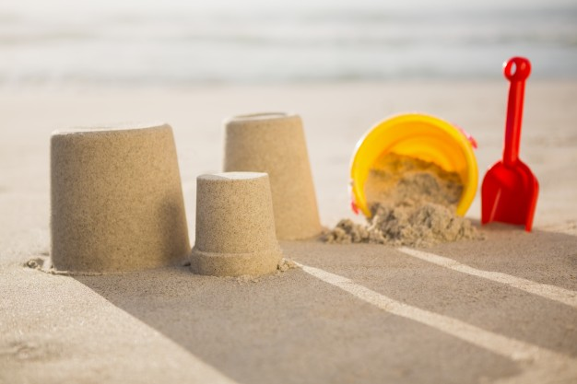

**Music.**

It would be lovely if the children could begin to appreciate the sounds they could possibly hear the seaside? Could it be the growing crowds of people? The laughter and screams from excited children? What else could they hear?

**Science.**

During our science topic this half term the children will be seaside scientist! The children will be tasked with designing and opening their own mini museum next to the seaside which will be all about materials. The museum needs to include information on the variety of materials used in the modern world, properties of common materials, where materials come from and how useful they are. Therefore, children will undertake various experiments, classifications and research to enable them to open their museum.

**English:**

We will be using our knowledge of the seaside and the activities and feelings we have when visiting the seaside and writing a poem based on the seaside.

We will then use our growing knowledge of the seaside and the activities that people do at the seaside to right an explanation on things to do at the seaside.

Finally, we will use a film based on a visit to the seaside to write a narrative based on the seaside.

**Maths:**

We will start this half term with a unit on measurement. We will be looking at mass and capacity and learning through practical and engaging tasks. We will then move on to multiplication and division, followed by a little bit of work on fractions and finally looking at time. We will continue to work hard on our mental recall of number facts too! ☺

**History:**

This half term we will be looking at seaside holidays in our era and then looking at how these have changed since the Victorian times. We will be focusing on why people go to the seaside for holidays now and in the past, what activities people do and did at the seaside and finally we will be focusing on the location of places and how and why people travelled to these places.

**RE**

God And Creation – This unit children will develop their understanding and perception of God and will reflect upon their feelings of awe, wonder, delight and mystery in relation to the natural world.

**DT/Art**

Children will research, investigate, design and make a collage of the seaside using various materials. Children will look at various designs and then innovate to produce their own.

**PE.**

This theme introduces the children to games. Looking at how we can develop co-ordination, discipline, team work and tactics in a variety of settings.