R/Y1 Discovery Newsletter Summer 2 2020

Welcome back to the final half term of the year, for our Reception and Year 1 children and their lovely families.
We hope you have had a restful week enjoying the sun and are ready to tackle this final, and hopefully fun half term. We don’t know what these next few weeks will hold but we really hope we might get to have you all back in school safely, very very soon. We will continue to send you home learning timetables and resources until things return to our new normal. These will be posted on Dojo on a Friday ready for the week ahead.
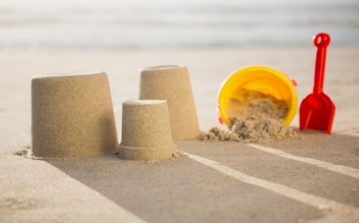
Our topic for Year 1 this half term is another perfect one for home learning - ‘Buckets and Spades’. Reception children, your focus will come under this umbrella but we will plan from stories for your activities.

As always, our topic webs can be viewed on the school website under:
Classes - Discovery - What’s new?
Home Learning- Curriculum Information:
As we’ve said before we both know how tricky home learning is! We can tell you that it is easier to teach a class of children rather than your own! So message us on Dojo if you need anything at all. Mrs Mesghali will be available on Monday and Tuesday. Mrs Lever will be available on Wednesday, Thursday and Friday.
Reception and Year 1 learning will be outlined in the timetables sent across to you weekly. We hope organising them this way has helped you all Please remember, all learning is optional and not meant to be onerous. Go with how you and your child are doing on a daily basis. We have signposted you to daily Maths, English, phonics, reading and spelling with two topic activities weekly but do not worry if you don’t get through it all.

Thank you for everything you are doing at home. You’re all wonderful! Keep sending us pictures and posting on your portfolios – we love seeing them.

We are missing all our families and children so much.
Please take care, stay in touch, be safe and we will hopefully see you all very soon.

With our very best wishes and love to you all,

Mrs. Lever and Mrs Mesghali

