Hoole St Michael CE Primary School Spring 1 Year 5/6
Computing: What did the Islamic Golden Age offer?
This half term we will be using the internet safely to design and make a presentation about an aspect of the Golden Age of Islam. Children will use mind mapping software such as Popplet or Mindmap to plan their work and then create an interactive presentation.
DT: Varjak Paw
How do cats move their mouths? In this half term, we will be exploring the use of cams to create movement. Once we have done this, we will then be designing a character from Varjak’s mean family to re-create a scene from the story. We will be exploring the mechanisms that can be made using cams and deciding how we want our cat to move their mouth.
History: Baghdad in 900AD – the round city!
This half term we will be exploring the Golden Age of Islam and the inventions that were created during this period. Although short-lived, the rise of Baghdad as a city of trade and knowledge opened the door to astronomical discoveries, the camera and even the invention of paper! We will be examining a variety of historical sources and unpicking what life was like in the ‘City of Peace’ and how the city fell.
PE: Arabian themed dance with South Ribble Sports
Look out for our performance on Dojo!
Daily Mile
RE: Prayer Spaces Epiphany
Christians and the Eucharist
Multi Faith Week - Sikhism
Science: Using the inventions of the Islamic Golden Age as a theme, we will be looking at forces and how they affect our everyday lives. We will explore modern day inventions like the car and the bike as well as items we use for pleasure such as snowboards. We will be working scientifically by exploring the parachute and how we can affect the speed in which it slows down to the ground.
Key Vocabulary: friction, air resistance, water resistance, gravity, grip, slip, equal and opposite forces.
English: Welcome to Mesopotamia! Join Endeavour as we journey to the Middle East with Varjak Paw by the author S.F Said. We will be using our novel all about cats and the legend of Jalal to inspire different kinds of writing in role. We will then move on to looking at the key rivers of the region: the Euphrates and the Tigris. We will be making explanation texts about these rivers in the form of magazine pages. Look out for our hybrid writing with persuasive adverts in there for the House of Wisdom and key information about great inventions of the time.
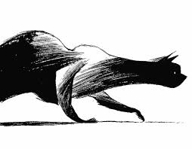
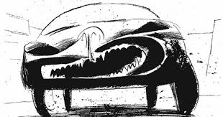
Arabian Nights

